* Project Overview:

This project streamlines HR hiring and retention by using data-driven automation to reduce time, costs, and resources, enabling companies to focus on core business activities.

* Problem Statement:

This project addresses the costly and time-intensive HR tasks of hiring and retention, especially for small businesses. By optimizing HR processes, it aims to cut costs and save time, allowing companies to focus more on growth and productivity.

1. Employee Retention Challenges and Solutions: Insights by Key Factors.
2. Distance-Related Employee Retention Challenges and Solutions.
3. Problem Statement with Possible Solutions for High Attrition Roles
4. Problem Statement with Possible Solutions for High Attrition by Marital Status
5. Problem Statement with Possible Solutions for High Attrition by Tenure

* Project Objective:

This project aims to identify employees at risk of quitting job and analyze the factors influencing their decisions. It will explore reasons for leaving, motivations for staying, and strategies to boost engagement and retention.

* Employee Retention Challenges and Solutions: Insights by Key Factors

1. Age

* Problem: Employees who left the company tend to be younger, suggesting that they may feel less stable or engaged in their roles compared to older employees.
* Solution: Implement targeted retention strategies for younger employees, such as mentorship programs, opportunities for skill development, and creating a clear career progression path to enhance engagement and job satisfaction. Additionally, foster a supportive work culture that aligns with their values and promotes work-life balance.

2. Daily Rate

* Problem: Employees who left the company tend to have a lower mean daily rate, suggesting that inadequate compensation may be a significant factor in their decision to leave.
* Solution: Regularly review and adjust compensation packages to ensure they are competitive within the industry. Implement performance-based raises and bonuses to reward high-performing employees and attract new talent.

3. Distance from Home

* Problem: Employees who left the company often lived farther from the workplace, potentially leading to increased dissatisfaction and higher likelihood of departure due to long commutes.
* Solution: Offer remote work options and flexible scheduling to accommodate employees with longer commutes. Additionally, consider subsidizing transportation costs or providing relocation assistance for employees willing to move closer to the office.

4. Environment Satisfaction

* Problem: Employees who left reported lower levels of satisfaction with their work environment, indicating that a negative workplace culture may have contributed to their decision to leave.
* Solution: Foster a positive workplace culture by promoting open communication and encouraging team-building activities. Regularly seek employee feedback and make changes based on their suggestions to ensure they feel valued and heard.

5. Job Satisfaction

* Problem: Employees who left generally experienced lower job satisfaction, suggesting that misalignment between their roles and responsibilities and their expectations may have influenced their departure.
* Solution: Conduct regular assessments of job roles to ensure alignment with employees' skills and career aspirations. Provide opportunities for professional development, role enhancements, and lateral moves within the organization to increase job satisfaction.

6. Stock Option Level

* Problem: Employees who left tended to have lower stock option levels, indicating that a lack of long-term incentives may have diminished their motivation to stay with the company.
* Solution: Consider increasing stock options and long-term incentive plans for all employees. This approach helps align their interests with the company's success, making them feel financially invested in the organization’s future.
* Distance-Related Employee Retention Challenges and Solutions.
* Problem:
* High Attrition in Closer Ranges: Employees who left the company often lived within 1-10 km, with this group showing the highest attrition (54 employees), suggesting possible dissatisfaction with their roles.
* Decreased Retention with Distance: Retention rates drop significantly for employees living 10 km or more away, while those in the 1-10 km group exhibit the highest retention (365 employees).
* Solution:
* Flexible Work Options: Introduce remote or hybrid work models to enhance job satisfaction and accommodate varying commuting preferences.
* Commuting Support: Provide transportation subsidies or incentives to assist employees with longer commutes, making it easier for them to remain with the company.
* Engagement Initiatives: Foster a sense of connection through team-building activities, recognition programs, and regular communication to keep employees engaged and valued.
* Targeted Strategies: Focus on the needs of employees living within 1-10 km, while also enhancing support for those commuting from farther distances, ensuring both groups feel supported and connected to the organization.

These strategies aim to improve employee retention by addressing the challenges posed by distance and commuting, enhancing overall job satisfaction.

* Problem Statement with Possible Solutions for High Attrition Roles

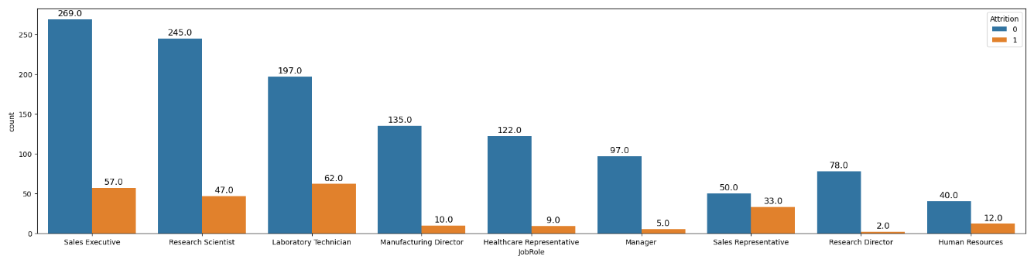

* Laboratory Technicians saw a higher number of people leave.
* Possible Solutions: Enhance job satisfaction by providing growth opportunities, a better work-life balance, and competitive pay. Regular training programs and career advancement options can help keep technicians engaged and reduce turnover.
* Research Scientists had some people leave, though most stayed.
* Possible Solutions: Offer more collaborative projects and innovation opportunities to increase engagement. Conduct job satisfaction surveys to identify and address reasons for turnover, creating a more motivating environment.
* Sales Executives saw a good number stay, though some left.
* Possible Solutions: Develop rewards programs to recognize achievements, enhance career progression, and encourage team bonding. A supportive team culture and clear growth opportunities can help reduce turnover among Sales Executives.
* Sales Representatives had a noticeable number leave compared to those who stayed.
* Possible Solutions: Introduce mentorship and training programs to build skills and increase job satisfaction. Establishing a supportive sales culture and offering performance-based incentives may also help improve retention in this role.
* Problem Statement with Possible Solutions for High Attrition by Marital Status

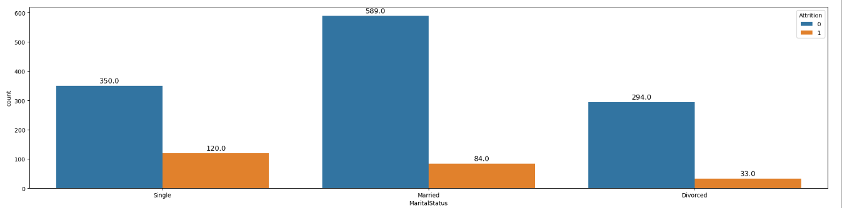

* Divorced employees had a notable number of departures.
* Possible Solutions: Provide support programs such as counseling services and flexible work arrangements to help employees manage personal challenges. Creating a supportive community within the workplace can also enhance engagement and retention.
* Single employees had a significant number of people leave.
* Possible Solutions: Implement social and team-building activities to foster a sense of belonging among single employees. Offering professional development opportunities and mentorship can also help increase job satisfaction and reduce turnover.
* Married employees also experienced some attrition, though less than divorced and single employees.
* Possible Solutions: Encourage work-life balance through flexible schedules and family-oriented benefits. Regular feedback sessions to understand their needs and career aspirations can also help in improving retention among married employees.
* Problem Statement with Possible Solutions for High Attrition by Tenure
* Employees with less than 1 year of tenure had the highest turnover.
* Possible Solutions: Improve the onboarding process to ensure new hires feel welcomed and supported. Implement mentorship programs to help them integrate into the company culture and understand their roles better.
* Employees with 2-3 years of tenure also experienced notable attrition.
* Possible Solutions: Offer opportunities for professional growth, such as additional training and career advancement paths. Conduct regular check-ins to gauge job satisfaction and address any concerns that may lead to turnover.
* Employees with 7-8 years of tenure had a significant number of departures.
* Possible Solutions: Engage these employees through leadership roles in projects or strategic initiatives. Recognize their contributions and provide incentives for staying with the company longer.